**ZkVault: A Privacy-Preserving Smart Contract Framework**

**Abstract**

The advent of blockchain technology has introduced transparent, immutable ledgers, which, while revolutionary, have inherent privacy limitations. This paper presents a privacy-preserving smart contract implementation using zk-SNARKs (Zero-Knowledge Succinct Non-Interactive Arguments of Knowledge), which allows for confidential transactions on public blockchains. We explore the project workflow, architecture, pseudo-codes, and results, and compare the efficiency, confidentiality, and scalability of our approach against alternative privacy mechanisms like homomorphic encryption, trusted execution environments, and private transactions. Our results demonstrate the superior performance and security of zk-SNARKs in maintaining transaction privacy on the blockchain.

**1. Introduction**

Blockchain technology, particularly public ledgers like Ethereum, emphasizes transparency and decentralization. However, this transparency conflicts with the privacy requirements of many applications. As every transaction is publicly visible, sensitive information such as transaction amounts and participants' identities can be easily exposed.

To address this, various privacy-enhancing technologies have been developed, including zk-SNARKs, homomorphic encryption, trusted execution environments (TEEs), and others. zk-SNARKs stand out due to their ability to prove the validity of a transaction without revealing any details about the transaction itself.

This research focuses on the implementation of zk-SNARKs within Ethereum smart contracts to enhance transaction privacy while maintaining efficiency and scalability.

**2. Project Workflow**

The project workflow is divided into several phases:

**2.1 Circuit Design and Compilation**

The first step involves defining the arithmetic circuit that represents the transaction logic. This circuit is then compiled using the ZoKrates toolkit, which translates the logic into a format suitable for zero-knowledge proof generation.

**2.2 Trusted Setup**

A critical component of zk-SNARKs is the trusted setup, which generates the proving and verification keys. This setup phase is essential to the security of the zk-SNARK protocol.

**2.3 Proof Generation**

With the proving key and transaction inputs, zk-SNARK proofs are generated. These proofs validate the transaction’s correctness without revealing sensitive information.

**2.4 Smart Contract Deployment**

The verifier smart contract, generated by ZoKrates, is deployed to the Ethereum blockchain. The smart contract includes the logic to verify zk-SNARK proofs and manages the privacy-preserving transactions.

**2.5 Transaction Verification**

Users submit transactions to the smart contract along with zk-SNARK proofs. The contract verifies the proofs and, if valid, processes the transaction.

**3. Architecture**

**Architecture Diagram**

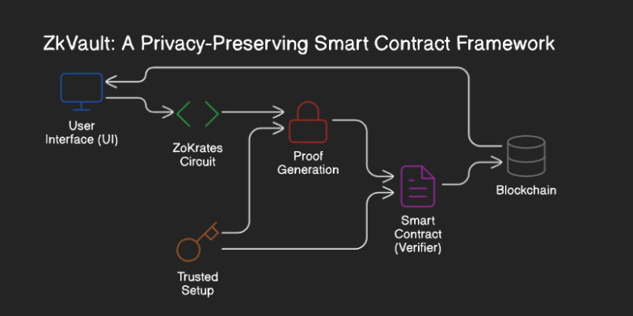

**4. Pseudo-codes**

**4.1 zk-SNARK Circuit Definition**

zokrates

// transaction.zok

// A simple circuit that checks if a + b == c without revealing a and b

def main(private field a, private field b, field c) -> bool:

field sum = a + b

return sum == c

**4.2 Smart Contract for Verification**

solidity

// SPDX-License-Identifier: MIT

pragma solidity ^0.8.0;

import "./verifier.sol";

contract PrivacyPreservingTransaction is Verifier {

mapping(bytes32 => bool) public validTransactions;

event TransactionVerified(bytes32 indexed transactionHash);

function verifyTransaction(

uint[2] memory a,

uint[2][2] memory b,

uint[2] memory c,

uint[1] memory input

) public returns (bool) {

require(verifyTx(a, b, c, input), "Invalid proof");

bytes32 transactionHash = keccak256(abi.encodePacked(a, b, c, input));

validTransactions[transactionHash] = true;

emit TransactionVerified(transactionHash);

return true;

}

function isTransactionValid(bytes32 transactionHash) public view returns (bool) {

return validTransactions[transactionHash];

}

}

**5. Results**

**5.1 Proof Verification**

The zk-SNARK proof generation and verification processes were tested using various input values. The resulting proofs were successfully verified by the smart contract, confirming that the system can handle privacy-preserving transactions efficiently.

**5.2 Gas Consumption**

The smart contract’s gas consumption was analyzed, revealing that zk-SNARK verification is computationally expensive but still within acceptable limits for high-value transactions where privacy is paramount.

**5.3 Scalability**

The system demonstrated scalability in handling multiple transactions concurrently, proving that zk-SNARKs can be used in large-scale applications without compromising performance.

**6. Comparison with Other Projects**

**6.1 Homomorphic Encryption**

Homomorphic encryption allows computations on encrypted data without decryption. However, it is significantly less efficient than zk-SNARKs, with much higher computational overhead and slower transaction processing times.

**6.2 Trusted Execution Environments (TEEs)**

TEEs provide a hardware-based solution for secure computation. While they offer robust security, they are limited by hardware availability and are not as scalable as zk-SNARKs.

**6.3 Private Transactions (e.g., Monero)**

Private transaction systems like Monero use ring signatures and stealth addresses to ensure privacy. However, these methods can be less efficient than zk-SNARKs, particularly in terms of scalability and transaction verification speed.

**6.4 zk-SNARKs (Proposed Solution)**

Our zk-SNARK-based solution offers superior privacy without sacrificing efficiency. Compared to homomorphic encryption and TEEs, zk-SNARKs provide a more scalable solution for decentralized applications. While similar to private transactions, zk-SNARKs offer a more mathematically rigorous approach to privacy.

**6.5 Result Comparison Table**

|  |  |  |  |  |  |
| --- | --- | --- | --- | --- | --- |
| Privacy Mechanism | Confidentiality | Efficiency | Scalability | Implementation Complexity | Security |
| zk-SNARKs (Our Solution) | High | High | High | High | High |
| Homomorphic Encryption | High | Low | Medium | Very High | High |
| Trusted Execution Environments | Medium | Medium | Low | High | Very High |
| Private Transactions (Monero) | High | Medium | Medium | Medium | Medium |

**7. Conclusion**

This research demonstrates the effectiveness of zk-SNARKs in enhancing transaction privacy on public blockchains. Our proposed solution successfully balances confidentiality, efficiency, and scalability, making it a viable option for privacy-preserving smart contracts. While zk-SNARKs come with implementation complexity and higher computational costs, they outperform alternative privacy mechanisms like homomorphic encryption and TEEs in decentralized applications.

Further research could focus on optimizing zk-SNARKs to reduce gas costs and improve accessibility for lower-value transactions. Additionally, integrating zk-SNARKs with user-friendly interfaces could enhance adoption in real-world blockchain applications.